Here's a production-style Linux lab on finding files. This is the kind of task a Linux Administrator or DevOps Engineer performs regularly.

🧪 LAB: Find a File in Linux
🎯 Scenario
A developer tells you:
"I don't know where the database.conf file is located on the server."
Your job is to locate it quickly.

⚙️ Step 1: Create a Directory Structure
mkdir -p find_lab/{config,backup,logs}
cd find_lab
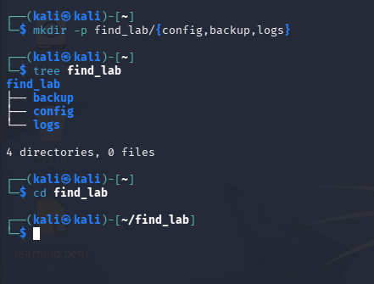

⚙️ Step 2: Create Sample Files
touch config/database.conf
touch config/nginx.conf
touch backup/database.conf.bak
touch logs/app.log
touch logs/error.log
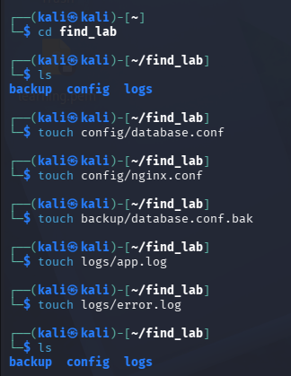
Verify:
find .
Expected output:
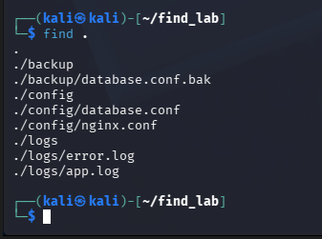
.
./config
./config/database.conf
./config/nginx.conf
./backup
./backup/database.conf.bak
./logs
./logs/app.log
./logs/error.log

⚙️ Step 3: Find an Exact File
find . -name "database.conf"
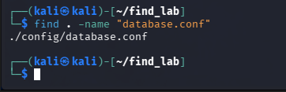
Expected output:
./config/database.conf

⚙️ Step 4: Find All Configuration Files
find . -name "*.conf"
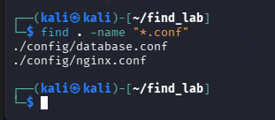
Expected output:
./config/database.conf
./config/nginx.conf

⚙️ Step 5: Find Files Ignoring Case
find . -iname "*.CONF"
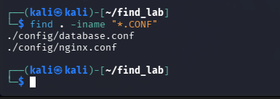
This finds .conf, .CONF, .Conf, etc.

⚙️ Step 6: Find Log Files
find . -name "*.log"
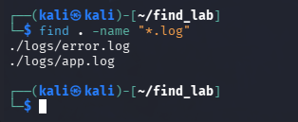
Expected output:
./logs/app.log
./logs/error.log

⚙️ Step 7: Find Directories Only
find . -type d
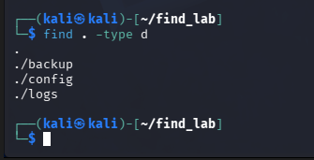
Expected output:
.
./config
./backup
./logs

⚙️ Step 8: Find Files Only
find . -type f
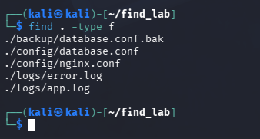
Expected output:
./config/database.conf
./config/nginx.conf
./backup/database.conf.bak
./logs/app.log
./logs/error.log

🌍 Production Scenario
A web application fails because it cannot load its configuration.
Instead of searching manually through hundreds of folders, an administrator runs:
find /etc -name "nginx.conf"
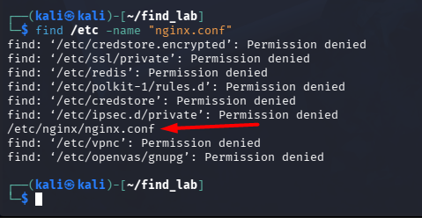
or
find /opt -name "application.properties"
to quickly locate the required file.

🎤 Interview Answer
"I used the find command to locate files and directories by name, type, and extension. This is commonly used in production to locate configuration files, log files, backups, and application resources during troubleshooting."

🚀 Bonus Challenge
Create these files:
project/
├── app.conf
├── app.log
├── database.sql
├── notes.txt
└── backup/
└── app.conf.bak
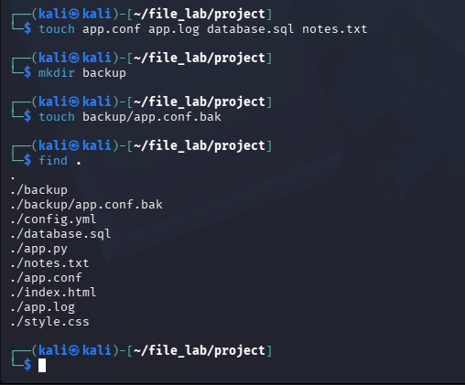
Now try to find:
- Only .conf files
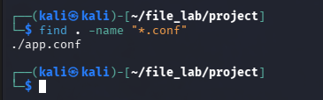

- Only .log files
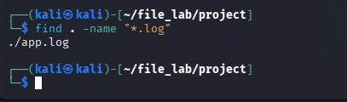

- Only directories
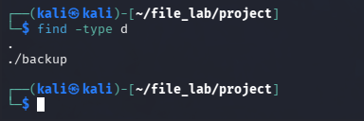
- Only .bak files
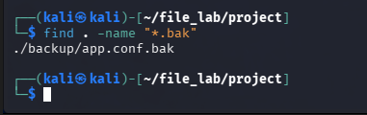
- Only regular files
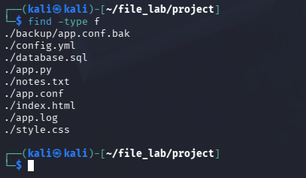
This lab gives you practical experience with one of the most frequently used Linux commands in production environments.

